--move the input file into Hdfs path and check for the input file



--register and define the jar to load the csv file



--do the data cleaning and transformation in pig



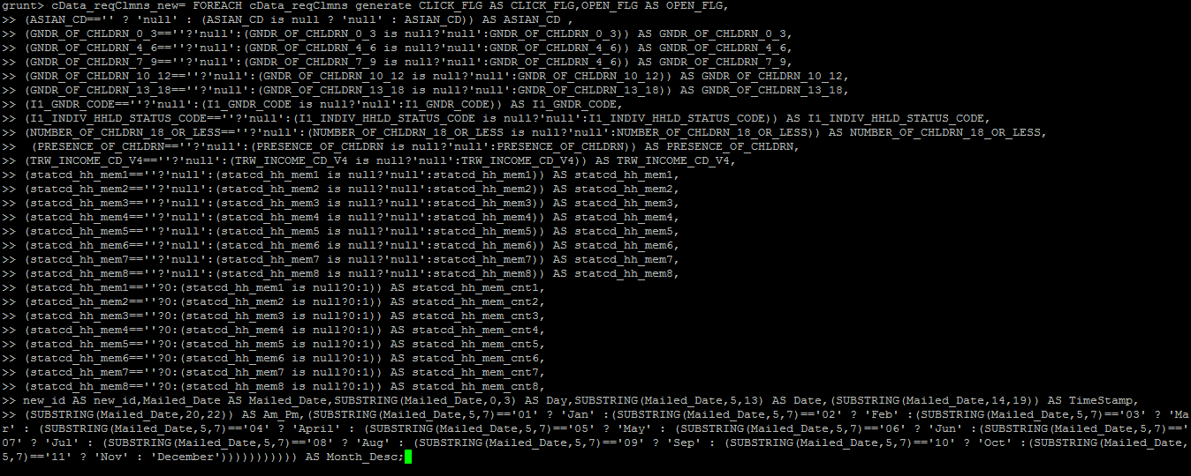

Store the output from pig in hdfs

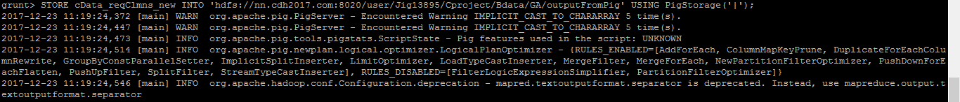

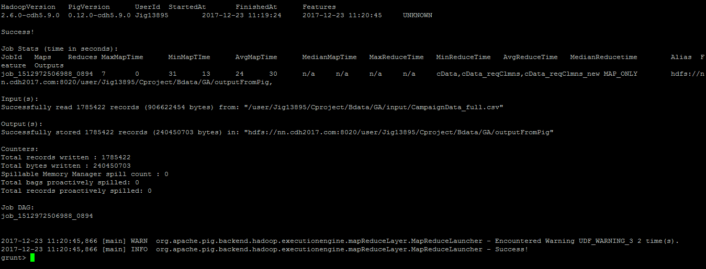

--check for the output file

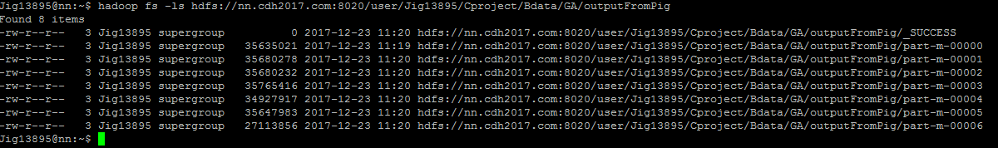

--create table in hive;

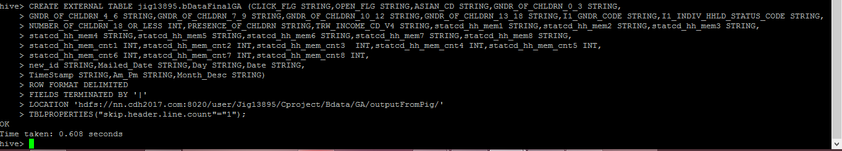

--check the data in the table

select count(*) from jig13895.bDataFinalGA;

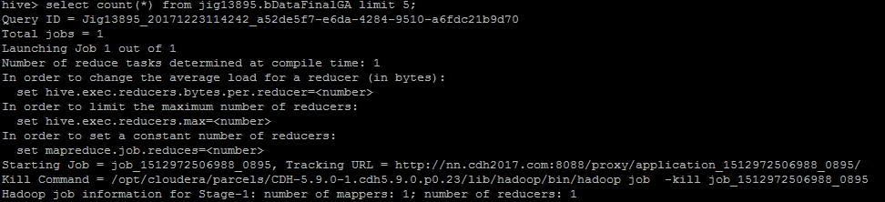

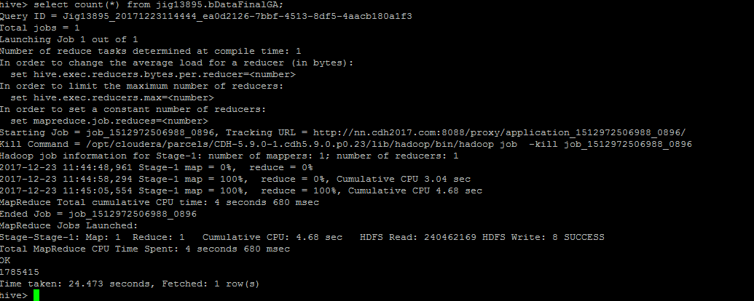

**Questions:**

**1.Find the Click To Open Rate i.e overall CTOR**

SELECT ROUND(SUM(CASE WHEN CLICK_FLG='Y' THEN 1 ELSE 0 END)/count(*)*100,2)

from jig13895.bdatafinalga where OPEN_FLG='Y';

o/p: 13.55

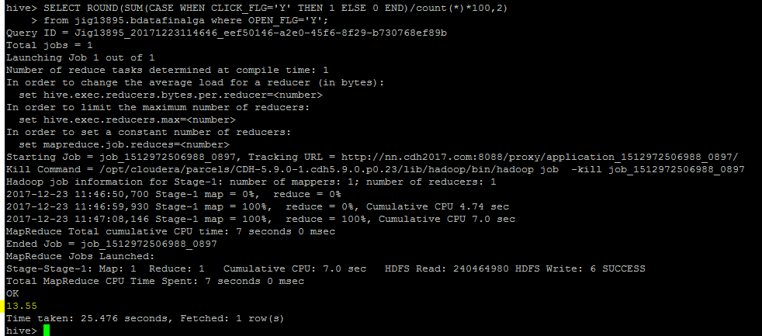

**--Find CTOR by gender**

SELECT I1_GNDR_CODE,ROUND(SUM(CASE WHEN CLICK_FLG='Y' THEN 1 ELSE 0 END)/count(*)*100,2)

from jig13895.bdatafinalga where OPEN_FLG='Y' GROUP BY I1_GNDR_CODE ORDER BY I1_GNDR_CODE;

o/p:

B 16.58

F 14.3

M 9.94

U 13.46

null 5.26

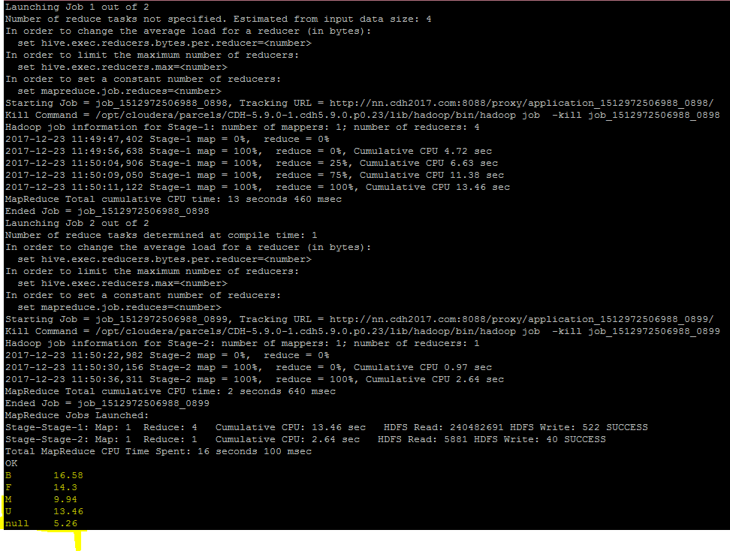

**--Find CTOR by time of the day**

SELECT TimeStamp,Am_Pm,ROUND(SUM(CASE WHEN CLICK_FLG='Y' THEN 1 ELSE 0 END)/count(*)*100,2)

from jig13895.bdatafinalga where OPEN_FLG='Y' GROUP BY TimeStamp,Am_Pm ORDER BY TimeStamp,Am_Pm;

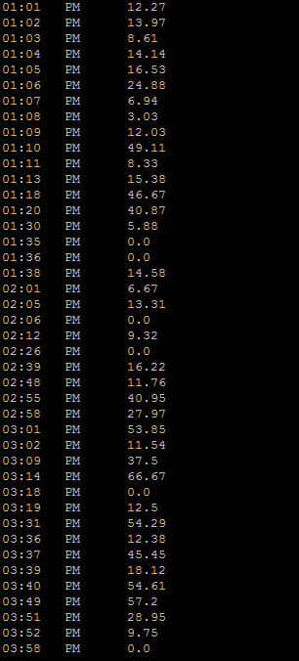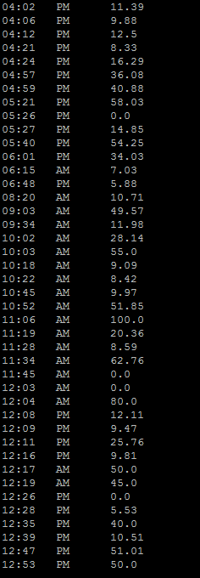

**--Find CTOR by Day of the week**

SELECT Day,ROUND(SUM(CASE WHEN CLICK_FLG='Y' THEN 1 ELSE 0 END)/count(*)*100,2)

from jig13895.bdatafinalga where OPEN_FLG='Y' GROUP BY Day ORDER BY Day;

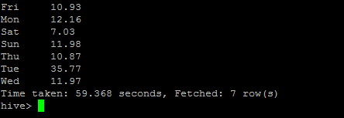

**--Find CTOR by Month**

SELECT Month_Desc,ROUND(SUM(CASE WHEN CLICK_FLG='Y' THEN 1 ELSE 0 END)/count(*)*100,2)

from jig13895.bdatafinalga where OPEN_FLG='Y' GROUP BY Month_Desc ORDER BY Month_Desc;

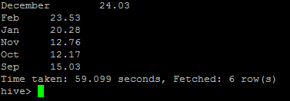

**--Find CTOR by Lead's Income group**

SELECT TRW_INCOME_CD_V4,ROUND(SUM(CASE WHEN CLICK_FLG='Y' THEN 1 ELSE 0 END)/count(*)*100,2)

from jig13895.bdatafinalga where OPEN_FLG='Y' GROUP BY TRW_INCOME_CD_V4 ORDER BY TRW_INCOME_CD_V4;

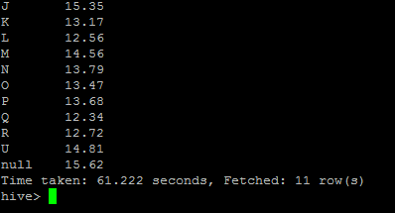

**--Find CTOR by Lead's Ethnicity**

SELECT ASIAN_CD,ROUND(SUM(CASE WHEN CLICK_FLG='Y' THEN 1 ELSE 0 END)/count(*)*100,2)

from jig13895.bdatafinalga where OPEN_FLG='Y' GROUP BY ASIAN_CD ORDER BY ASIAN_CD;

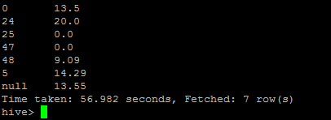

**--Find CTOR by Lead's Household status**

SELECT I1_INDIV_HHLD_STATUS_CODE,ROUND(SUM(CASE WHEN CLICK_FLG='Y' THEN 1 ELSE 0 END)/count(*)*100,2)

from jig13895.bdatafinalga where OPEN_FLG='Y' GROUP BY I1_INDIV_HHLD_STATUS_CODE ORDER BY I1_INDIV_HHLD_STATUS_CODE;

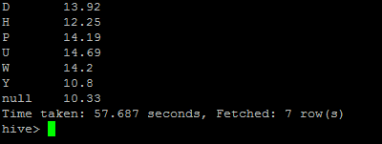

**Tableau Visualization Path**: 52.3.237.208 inside E: drive🡪users🡪jig13895🡪Documents🡪My Tableau Repository🡪workbooks🡪jig13895 Final Assignment

**2.Find Household members information**

**a.Find count of leads who has information about the members of household**

SELECT SUM (CASE WHEN statcd_hh_mem1 != "null" OR statcd_hh_mem2 != "null" OR statcd_hh_mem3 != "null" OR statcd_hh_mem4 != "null" OR statcd_hh_mem5 != "null" OR statcd_hh_mem6 != "null" OR statcd_hh_mem7 != "null" OR statcd_hh_mem8 != "null" THEN 1 ELSE 0 END ) AS total FROM jig13895.bdatafinalga;

o/p-->1785317

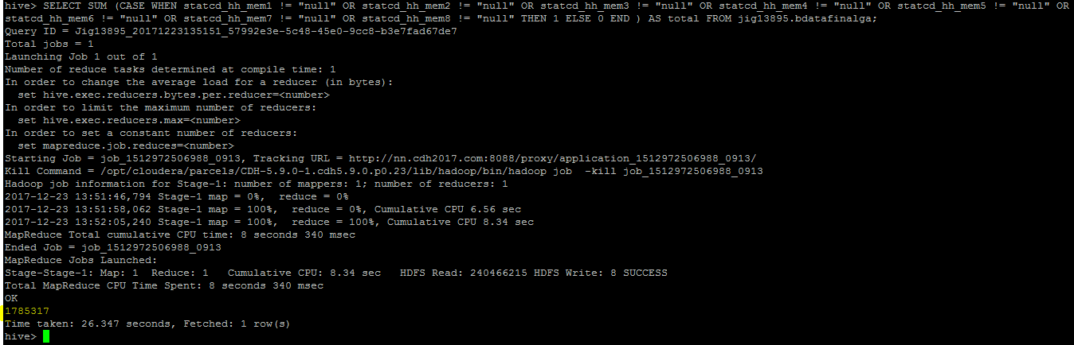

**b.Find count of household number of household members**

SELECT SUM(statcd_hh_mem_cnt1+statcd_hh_mem_cnt2+statcd_hh_mem_cnt3+statcd_hh_mem_cnt4+statcd_hh_mem_cnt5+statcd_hh_mem_cnt6+statcd_hh_mem_cnt7+statcd_hh_mem_cnt8) from jig13895.bdatafinalgasampleNew;

o/p--> 4053931

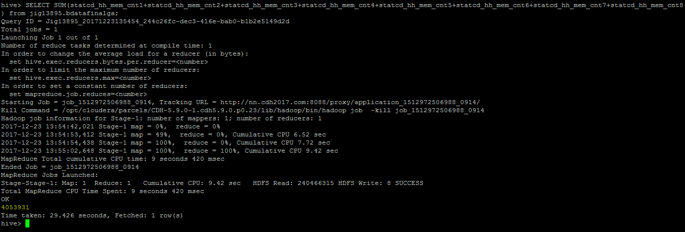

**c.Find count of household members by type**

SELECT SUM((CASE WHEN statcd_hh_mem1 == "U" THEN 1 ELSE 0 END) +

(CASE WHEN statcd_hh_mem2 == "U" THEN 1 ELSE 0 END)+

(CASE WHEN statcd_hh_mem3 == "U" THEN 1 ELSE 0 END)+

(CASE WHEN statcd_hh_mem4 == "U" THEN 1 ELSE 0 END)+

(CASE WHEN statcd_hh_mem5 == "U" THEN 1 ELSE 0 END)+

(CASE WHEN statcd_hh_mem6 == "U" THEN 1 ELSE 0 END)+

(CASE WHEN statcd_hh_mem7 == "U" THEN 1 ELSE 0 END)+

(CASE WHEN statcd_hh_mem8 == "U" THEN 1 ELSE 0 END)) FROM jig13895.bdatafinalga;

o/p-->1417182

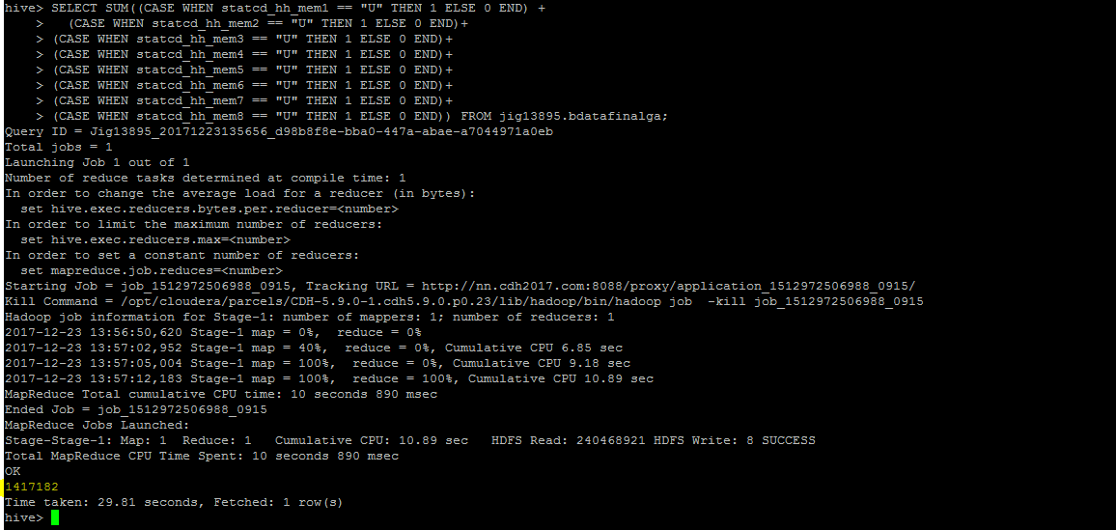

**d. Find % of household members type**

SELECT ROUND((SUM((CASE WHEN statcd_hh_mem1 == "U" THEN 1 ELSE 0 END) +

(CASE WHEN statcd_hh_mem2 == "U" THEN 1 ELSE 0 END)+

(CASE WHEN statcd_hh_mem3 == "U" THEN 1 ELSE 0 END)+

(CASE WHEN statcd_hh_mem4 == "U" THEN 1 ELSE 0 END)+

(CASE WHEN statcd_hh_mem5 == "U" THEN 1 ELSE 0 END)+

(CASE WHEN statcd_hh_mem6 == "U" THEN 1 ELSE 0 END)+

(CASE WHEN statcd_hh_mem7 == "U" THEN 1 ELSE 0 END)+

(CASE WHEN statcd_hh_mem8 == "U" THEN 1 ELSE 0 END)) ) /

(SUM(statcd_hh_mem_cnt1+statcd_hh_mem_cnt2+statcd_hh_mem_cnt3+statcd_hh_mem_cnt4+statcd_hh_mem_cnt5+statcd_hh_mem_cnt6+statcd_hh_mem_cnt7+statcd_hh_mem_cnt8)) * 100,2)

FROM jig13895.bdatafinalga;

o/p-->34.96

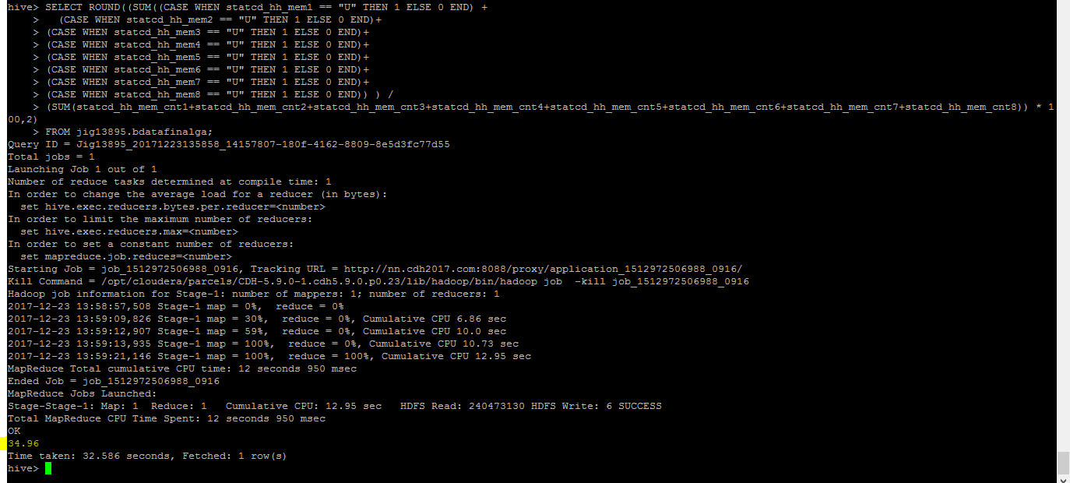

**e. how many households have children**

SELECT COUNT(*) FROM jig13895.bdatafinalga WHERE PRESENCE_OF_CHLDRN=="Y";

O/P-->782383

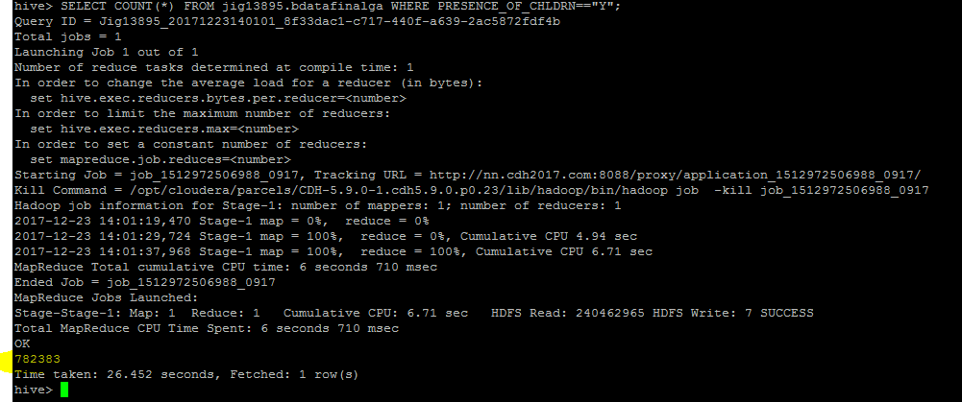

**f.Overall how many children are there**

SELECT SUM(NUMBER_OF_CHLDRN_18_OR_LESS) FROM jig13895.bdatafinalga WHERE PRESENCE_OF_CHLDRN=="Y";

o/p 🡪1417190

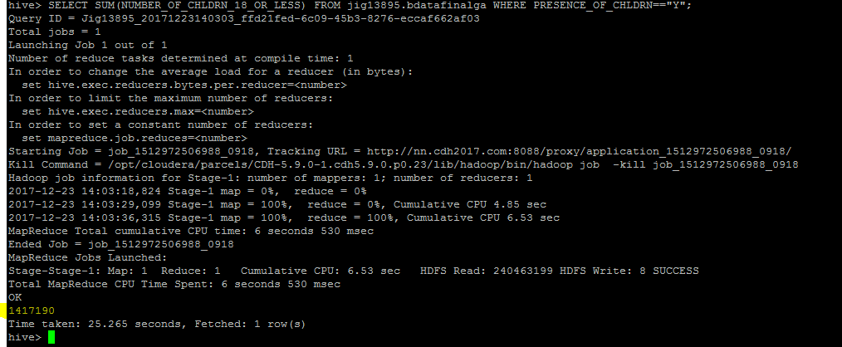

**g. how many of the children are male and female**

SELECT SUM((CASE WHEN GNDR_OF_CHLDRN_0_3 == "M" THEN 1 ELSE 0 END) +

(CASE WHEN GNDR_OF_CHLDRN_4_6 == "M" THEN 1 ELSE 0 END)+

(CASE WHEN GNDR_OF_CHLDRN_7_9 == "M" THEN 1 ELSE 0 END)+

(CASE WHEN GNDR_OF_CHLDRN_10_12 == "M" THEN 1 ELSE 0 END)+

(CASE WHEN GNDR_OF_CHLDRN_13_18 == "M" THEN 1 ELSE 0 END)) AS Males, SUM((CASE WHEN GNDR_OF_CHLDRN_0_3 == "F" THEN 1 ELSE 0 END) +

(CASE WHEN GNDR_OF_CHLDRN_4_6 == "F" THEN 1 ELSE 0 END)+

(CASE WHEN GNDR_OF_CHLDRN_7_9 == "F" THEN 1 ELSE 0 END)+

(CASE WHEN GNDR_OF_CHLDRN_10_12 == "F" THEN 1 ELSE 0 END)+

(CASE WHEN GNDR_OF_CHLDRN_13_18 == "F" THEN 1 ELSE 0 END)) AS Females FROM jig13895.bdatafinalga where PRESENCE_OF_CHLDRN=="Y" and new_id='160033';

o/p-->Males 281635; Females : 240726

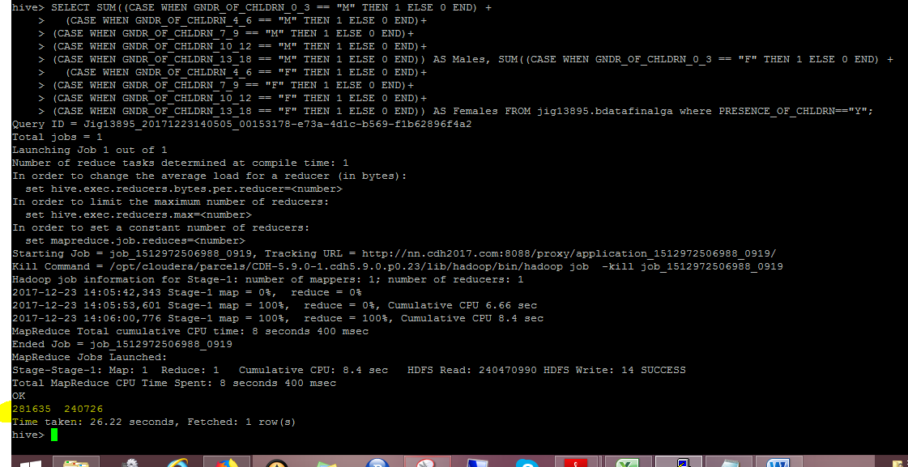

**Kindly find the scripts** 